Vision Slim Software Solution

Installation and Configuration Guide Version 4.18.0

Copyright and Trademark Information

The products described in this document are copyrighted works of NCR Corporation.

NCR, CxBanking, and APTRA are trademarks of NCR Corporation.  
Adobe and Reader are either registered trademarks or trademarks of Adobe Systems Incorporated in the United States and/or other countries.

Microsoft is a registered trademark or trademark of Microsoft Corporation in the United States and/or other countries.

All other trademarks are the property of their respective owners.

**Disclaimer:** It is the policy of NCR Corporation to improve products as technology, components, software, and firmware become available. NCR, therefore, reserves the right to change specifications without prior notice.

All features, functions, and operations described herein may not be marketed by NCR in all parts of the world. In some instances, photographs are of equipment prototypes. Therefore, before using this document, consult with your NCR representative or NCR office for information that is applicable and current.

© December 15, 2022  
By NCR Corporation  
Atlanta, Georgia, USA  
All Rights Reserved

Revision History

|  |  |  |  |
| --- | --- | --- | --- |
| Version | Date | Pages | Description of Change |
| 1.0 | 8/04/22 | All | Initial |
| 1.0 | 12/15/22 | 10 | Added SQL supported databases |

Table of Contents

Copyright and Trademark Information 1

Revision History 2

Table of Contents 3

Preface 4

Document conventions 4

Typographical conventions 4

Admonition conventions 4

Introduction 5

1. Installation Media 6

2. Installation Package Structure 7

3. Vision 4.18 Slim Server – Pre-Installation Prerequisites 8

3.1 Virtual Machine Configuration 8

3.2 Supported Operating System 8

3.3 Windows User / Service Account 8

3.4 Windows IIS 8

3.5 Firewall / Port Settings 9

4. Microsoft SQL Server - Pre-Installation Prerequisites 10

4.1 SQL Supported Databases 10

4.2 Database Properties Settings 10

4.3 Create a Vision Install SQL Login 12

5. Vision slim installer: Pre-upgrade & Pre-requisites 15

6. Installation Process 16

7. Uninstallation Process 24

8. Upgrade installation Process 25

9. Apache load balancer and certificate configuration 26

10. Vision Configuration 35

10.1 Security Role 35

10.2 Users 35

10.3 Category Names 35

10.4 Terminal Definition (Import) 36

10.5 Terminal Group Definition 36

# Preface

## Document conventions

## Typographical conventions

The following typographical conventions are used:

* + 1. Typographical conventions

|  |  |
| --- | --- |
| Style | Indicating |
| Bold | An option that you can select, for example, Insert > Bookmark |
| Bold Italic | The emphasis, for example, “This partition must not be modified.”  A physical key, for example, Shift+F9 |
| Code | Text displayed on-screen  Commands or data entered by the user  Code text and examples |
| Hyperlink | Links to Internet sites  Internal cross-references |
| Italic | The first reference to a keyword  The title of a publication, for example, Product Overview  A file or folder name, for example, C:\Program Files\NCR |

### Admonition conventions

Notes and cautions alert you to critical information. Each is displayed differently:

Note: Notes contain information that has special importance, to which the reader should pay close attention or tips with useful advice for the user on tasks or procedures.

* Caution: Cautions alert you to procedures or conditions that could damage equipment or data.
  + 1. Admonition conventions

| **Notes and cautions in tables** | | |
| --- | --- | --- |
| **Note:** Notes contain information that has special importance. | **Caution:** Cautions alert you to procedures or conditions that could damage equipment or data. |

Introduction

This document provides instructions to install/upgrade the Vision Slim installer. The slim installer exe is compatible with the below Vision versions

|  |  |
| --- | --- |
| Slim Installer exe version | Vision version |
| Vision4x_Installer_v1.0.9.exe | Vision 04.10.00.30 |
| Vision4x_Installer_v1.1.0.exe | Vision 04.13.01.01 |
| Vision4x_Installer_v1.2.0.exe | Vision 04.14.00.20 |
| Vision4x_Installer_v1.3.0.exe | Vision 04.15.00.13 |
| Vision4x_Installer_v1.4.0.exe | Vision 04.15.01.18 |
| Vision4x_Installer_v1.5.0.exe | Vision 04.16.00.82 |
| Vision4x_Installer_v1.6.0.exe | Vision 04.18.00.13 |

1. Installation Media

Copy the supplied Vision 4.18 installation media to a suitable and accessible location on the Vision Server. This contains all the necessary software to install the solution and will be referenced throughout this document.

1. Installation Package Structure

**Vision4x_Installer_v1.6.0.exe** is the setup file of Vision Slim 4.18.

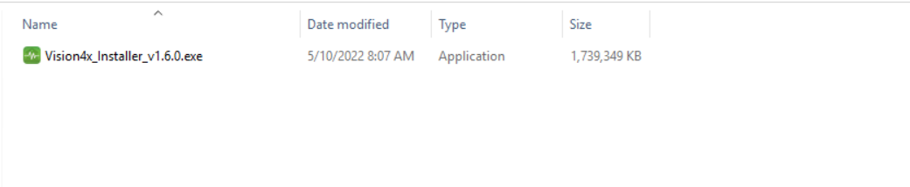

Figure 1

1. Vision 4.18 Slim Server – Pre-Installation Prerequisites

Perform the following tasks:

## Virtual Machine Configuration

Ensure that the configuration of the Vision 4.18 Server VM follows the vendor's recommended best practices.

The below references identify the best practice guidelines for **VMWare vSphere**:

Performance Best Practices for **VMWare vSphere 6.5**

<https://www.vmware.com/content/dam/digitalmarketing/vmware/en/pdf/techpaper/performance/Perf_Best_Practices_vSphere65.pdf>

Architecting Microsoft SQL Server on **VMWare vSphere**, Best Practice Guide

<https://www.vmware.com/content/dam/digitalmarketing/vmware/en/pdf/solutions/sql-server-on-vmware-best-practices-guide.pdf>

## Supported Operating System

* Windows Server 2012
* Windows Server 2016
* Windows Server 2019

**Note**: **UK or US Regional settings must be used when setting up the OS**

## Windows User / Service Account

A local windows user or local service account must be created with full Admin rights

## Windows IIS

IIS needs to be installed as windows feature and default website needs to be stopped / disabled

## Firewall / Port Settings

Physical firewall incoming and outgoing rules must be defined to allow communications on the following ports:

|  |  |  |  |  |  |
| --- | --- | --- | --- | --- | --- |
| Protocol | Port(s) | Vision 4.18 Application Server | Database Server | Client (ATM – Unified Agent and/or SWD Agent) | Client (Desktop Internet Explorer) |
| Microsoft SQL Server | 15010 | Directional | Directional | - | - |
| HTTPS | 443 | Bidirectional | - | ATM Unified Agent  Directional (outbound – client connects to server) | Directional (outbound – client connects to server) |
| HTTPS | 35010 | Bidirectional | - | - | Directional (outbound – client connects to server) |
| SMTP | 25 | Directional | - | - | - |
| SFTP  Used for authentication/authorization. Once authenticated, hands over to passive port for data transfer | ? | Directional  (Outbound–Vision server connects to NCR FTP server) | - | - | - |

Table 1

1. Microsoft SQL Server - Pre-Installation Prerequisites

It is assumed that Microsoft SQL Server 2017 (Standard Edition) and Microsoft SQL Server Management Studio have been pre-installed. Appendix E documents a typical installation process installing the features as required for a Vision 4.x solution.

## 4.1 SQL Supported Databases

* MS SQL Server 2016 (non-clustered)
* MS SQL Server 2017 (non-clustered)
* Ms SQL Server 2019 (non-clustered)

## 4.2 Database Properties Settings

1. Login to ***SQL Server Management Studio***.

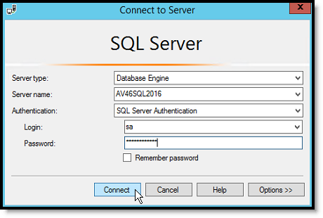

Figure 2

1. Right-click on the ***Database*** server and select the ***Properties*** option.

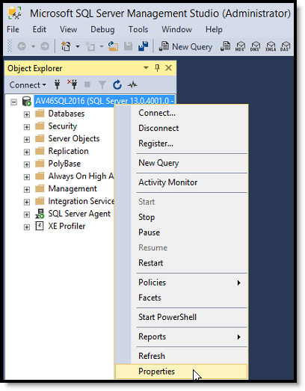

Figure 3

1. Select the Memory tab in the Server Properties pane and set the Maximum server memory.

The **Max Server Memory** value should be set to the amount of memory in the server minus approx. and 4GB for Windows operating system use. For example, if 20GB of memory is installed, set the Maximum server memory field to 16,386

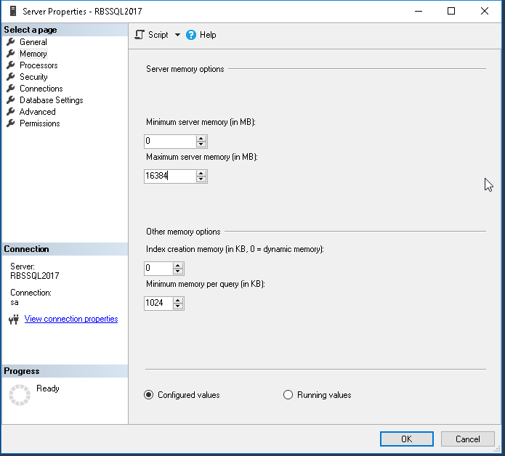

Figure 4.

1. Select the ***Advanced*** page and change "**Max Degree of Parallelism**" from **0** to **8**. (To minimize parallel query waits). Click on **OK** to accept the settings.

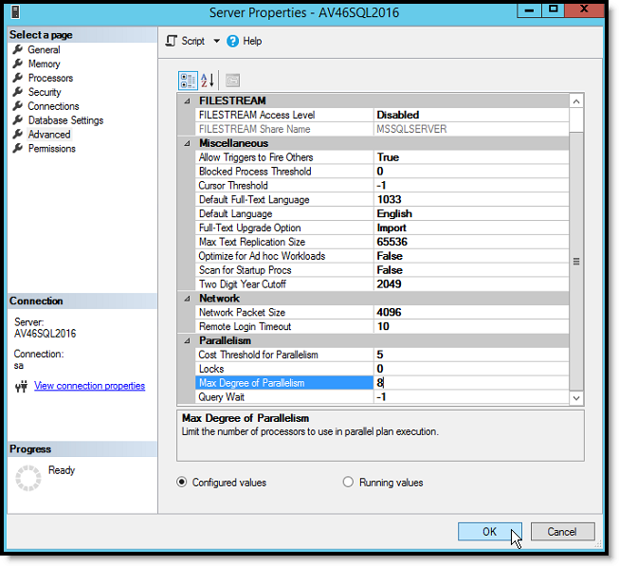

Figure 5

## 4.3 Create a Vision Install SQL Login

1. Login to **SQL Server Management Studio** (using sa or a Login name that has permissions to create a new Login)

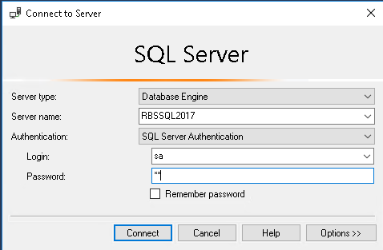

Figure 6

1. Expand the Object tree in Object Explorer to expose ***Security\Logins***. Right-click on ***Logins*** and select ***New Login*…**

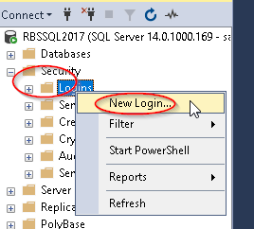

Figure 7

1. Set the login name to **VisionInstall**, select ***SQL Server authentication***, set the ***Password / Confirm password*** as same as the login name and ***uncheck*** the ***Enforce password policy*** box. Verify the ***Default database*** is set to **master**, then click on ***Server Roles*** in the left-hand pane

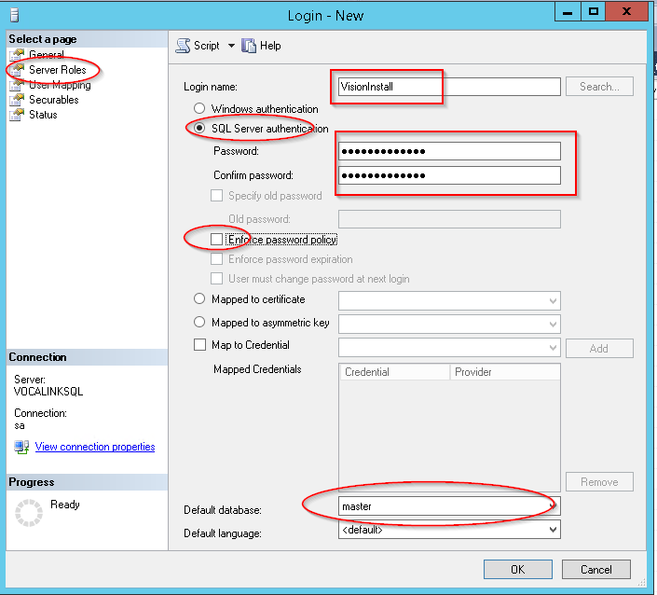

Figure 8

1. Select ***sysadmin*** and click on ***OK***

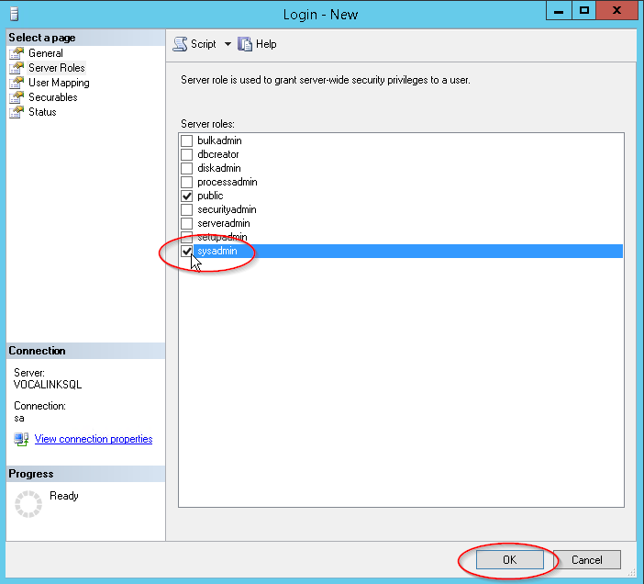

Figure 9

1. Verify that the Login has been correctly created and then exit ***SQL Server Management Studio***

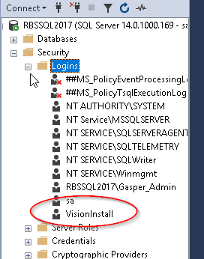

Figure 10

1. Vision slim installer: Pre-upgrade & Pre-requisites

If upgrading from Slim Installer 4.15.x or previous versions to the latest, follow the below steps to upgrade SOLR from 5 to SOLR 8.

* Stop ***ncr_vision_tomcat***
* The user needs to perform a commit to the SOLR core.
* Open the below URL from a browser of the app server:

[*http://localhost:8983/solr/electronicjournal/update?commit=true*](http://localhost:8983/solr/electronicjournal/update?commit=true)

1. Installation Process

The following sections provide concise descriptions of each task that must be performed as part of the installation process. These tasks must be executed in the order as documented

* **Caution**: **The installation / test strategy should be to installed using the included Apache24 load balancer initially, proving that all Vision functionality works. Once this is confirmed the system should be reconfigured to use the F5 load balancer**
* **Caution**: **Unless specified, all actions in this document apply to the Vision 4.18 server ONLY**

1. Before starting the installation, verify that the firewalls are configured to **BLOCK** all potential ATM traffic to prevent ATMs from registering with Vision inadvertently before the system is in a configured state.
2. Right-click on ***Vision4x_Installer_v1.6.0.exe*** and run the setup as administrator.

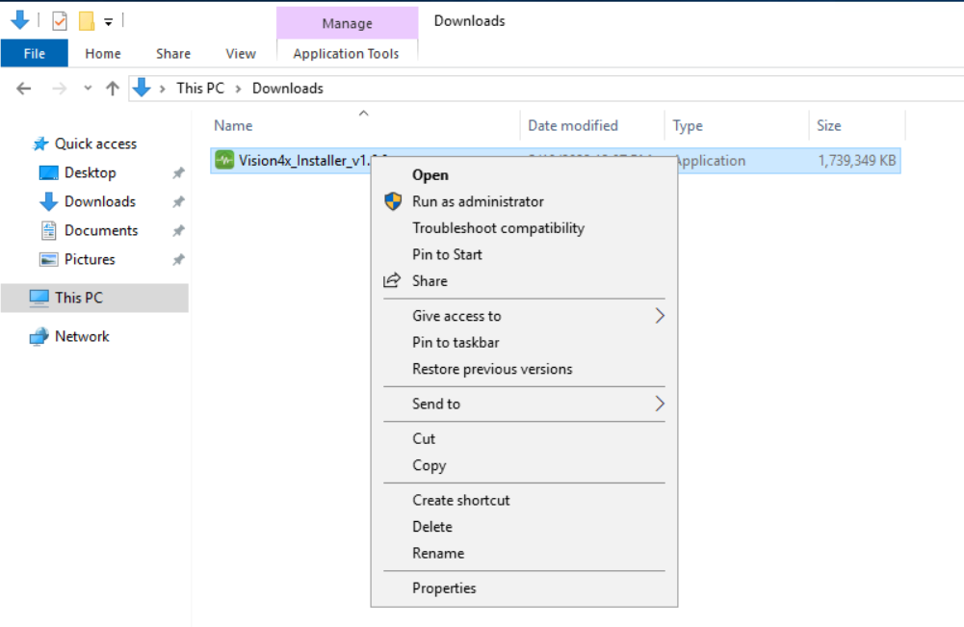

Figure 11

1. The initial setup steps will be performed, and the second self-extracting executable will be launched automatically

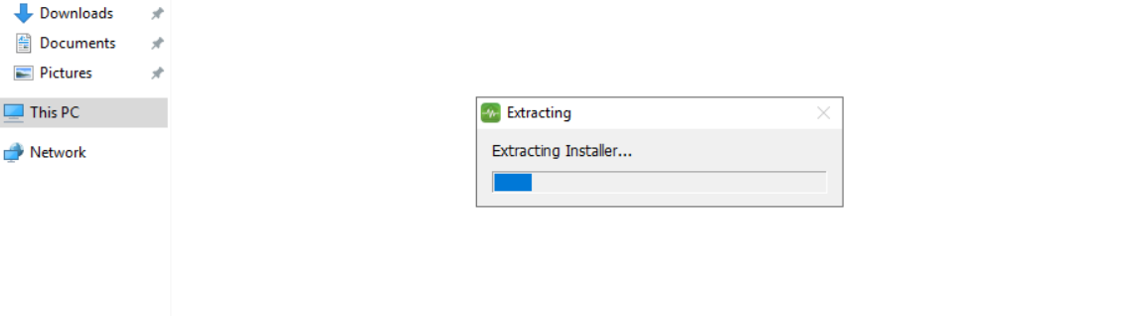

Figure 12

1. Specify a location to install the product, the default is **"*C:\ncr\vision*"** but we recommend using a different drive for the **OS installation** to prevent issues. If you are performing slim installer upgrade, specify the same location as used in the previous install.

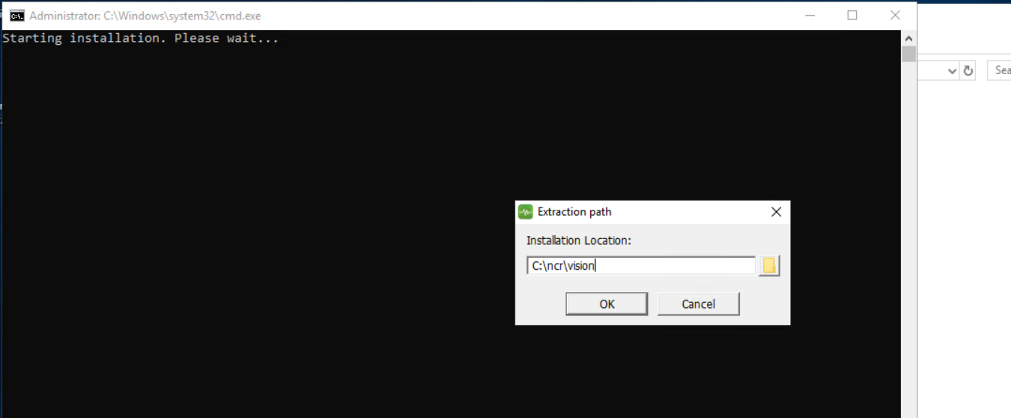

Figure 13

1. When the product is extracted, a ***PowerShell*** will begin executing to install the product without intervention. when completed, a pop-up will appear asking if the user wants to launch the configurator.

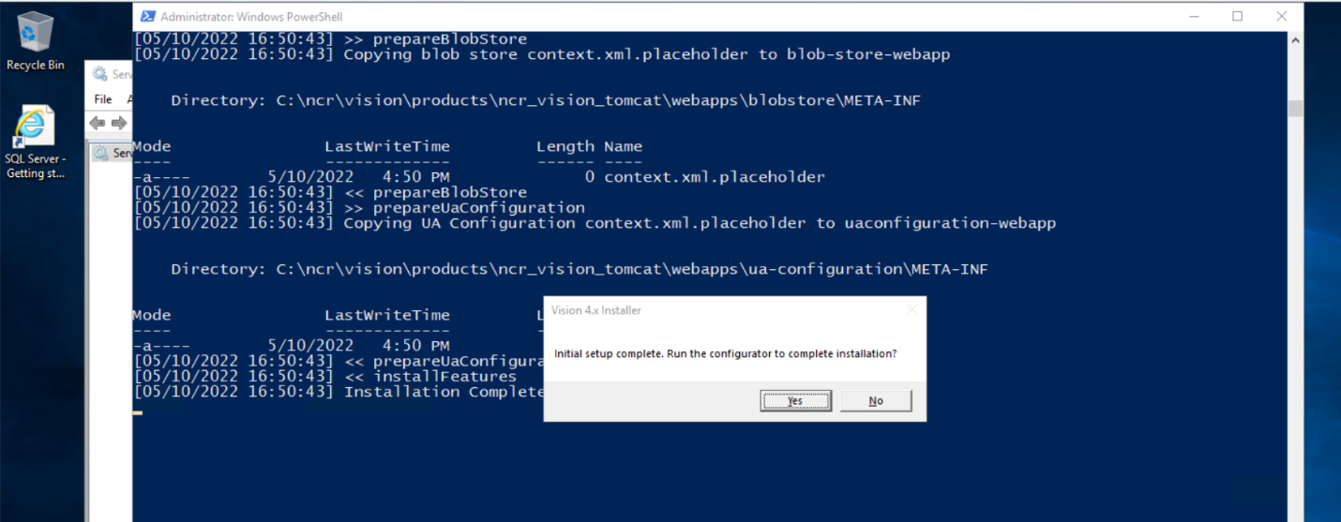

Figure 14

1. Select ***Next*** on **Select Applications to install** page.

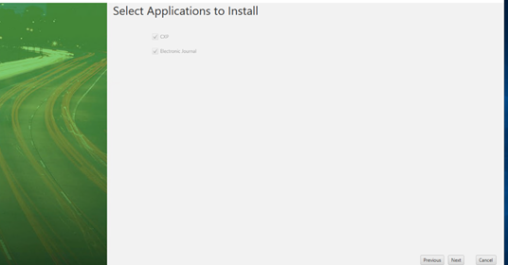

Figure 15

1. If **"yes"** was selected at the end of the last step the configuration utility will be launched. Otherwise, double-click the **"configure.bat"** file within the ***<Installation Directory>*** to launch the configuration utility.

Follow the steps in the Wizard to complete the installation and configure the system.

* 1. In **“Select applications to install”** screen, click on ***"Next"***.

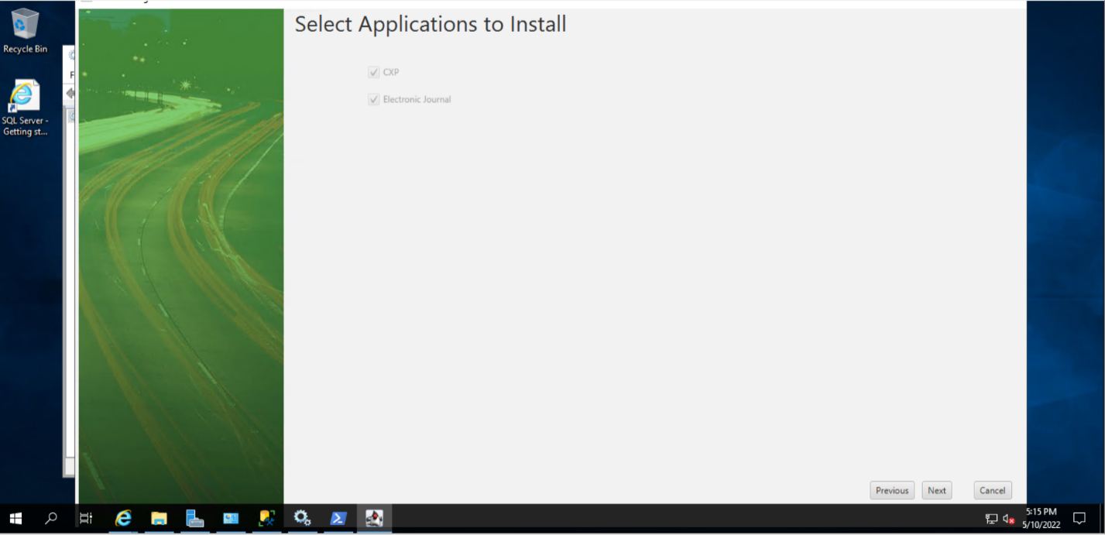

Figure 16

* 1. In **"Database Administrator Configuration"** screen, enter the following details:
* **Database Host** - The IP or Hostname of the database server
* **Database Port** - The port number that the database is running on
* **Database Username** - The **"system administrator"** (or SA) account on the database server
* **Database Password** - The password for the above account.

**NOTE**: The Password will not be stored.

* **Database Name** - The name of the database you wish to create.
* **Load Balancer IP** - The IP or hostname of the application server.

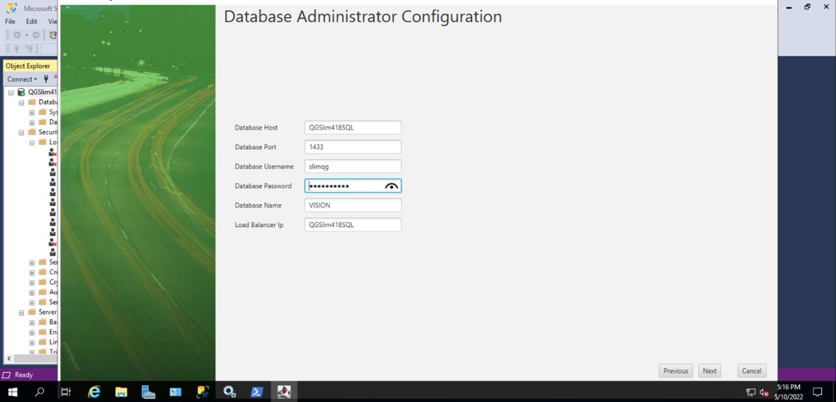

Figure 17

* 1. In **"CXP Settings"** screen, either enter new values for **"Cxp App Db Username"** and **"Cxp App Db Password"** or use the defaults. If you are performing slim installer upgrade, use the same **CXP DB username** and **password** as used in the previous install.

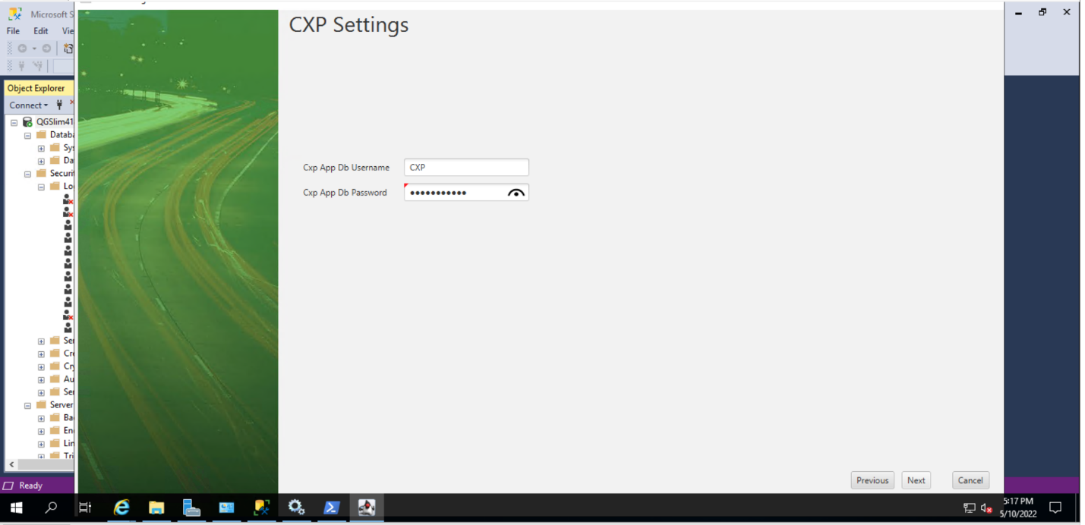

Figure 18

* 1. In **"Electronic Journal Settings"** screen, either enter new values for "EJ App Db Username" and "EJ App Db Password" or use the defaults. If you are performing slim installer upgrade, use the same EJ App Db username and password as used in the previous install.

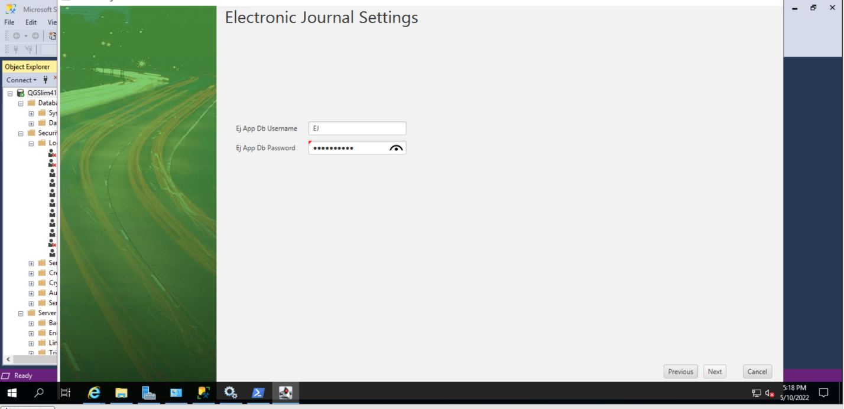

Figure 19

* 1. When ***"*Install*"*** is clicked, the configuration will begin. This will start by verifying the database connectivity and preparing the system.

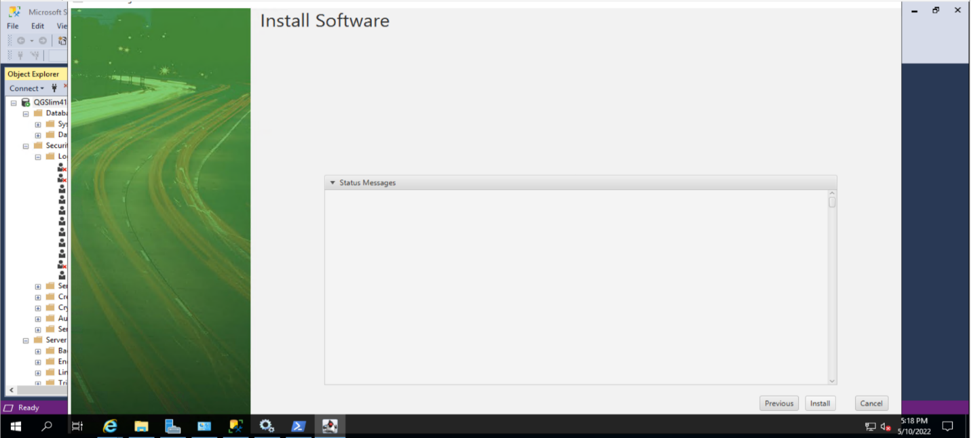

Figure 20

* 1. When the installation is completed, Click on **Finish** to complete the installation.

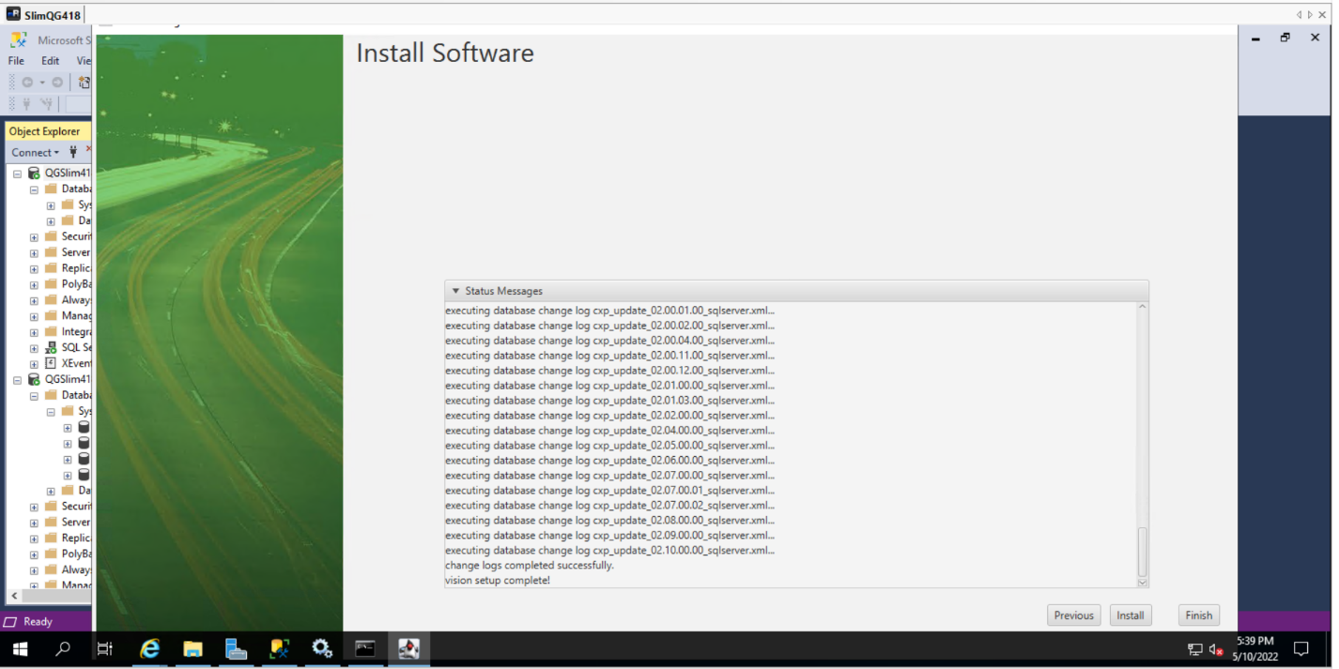

Figure 21

* 1. If upgrading from 4.15.x or previous versions to the latest follow the below steps to upgrade SOLR from 5 to SOLR 8.

**7.7.1)** Open command prompt as admin on ***install-location\dependencies\SolrUpgradeUtil***

**7.7.2)** Run ***RunToUpgradeSolrData.bat***

**7.7.3)** Open a web browser and open the below URL, it will ask for the username password, the default is **admin/admin** https://localhost:8983/solr/admin/collections?action=REINDEXCOLLECTION&name=upgradedataelectronicjournal&removeSource=true&target=electronicjournal&configName=electronicjournalSolr8&async=8888

**7.7.4)** Open the below URL and keep on reloading for a few minutes, wait until the response says completed

<https://localhost:8983/solr/admin/collections?action=REQUESTSTATUS&requestid=8888&wt=xml>

* 1. when the system is configured, the user can start the ***"ncr_vision_tomcat"*** service within the Windows Services (services.msc) snap-in.

**Note**: Also, make sure that the Log on user for ***ncr_vision_tomcat*** service has the privilege to read/write/modify.

When the system is finished loading, the user will be able to access the system using the load balancer IP that you have specified in step 5.

The default user credentials are admin / Password-100. On initial login, the user will be prompted to change the password.

**Note**: This may take time depending on the performance of the application server and database server.

Data loads for language translations and roles will be performed as the application comes up.

All installation activities are logged in a file named **ApplicationServerInstallation_*servername*.log** which is saved in the application install directory (e.g., D:\Vision4). Edit this file using a text editor and search for the word ‘**error**’

**Note**: Do not progress further with the installation and configuration process until any errors displayed are resolved

1. Uninstallation Process
2. Run the ***"cleanup-services.bat"*** file using an Administrator command prompt, provided in the folder.
3. Delete the ***<Installation Location>*** folder.

**Note**: The above steps will only remove the services and binaries added during installation. It will **NOT** make any modification to the Database.

1. Upgrade installation Process

**Note**: Create backups for the following Files/Folder at ***“<Application Directory>\ncr\”*** before the upgrade

* Dataload
* Logs
* cxp.properties
* cxp.properties.placeholder
* cxp.sqlserver.properties
* cxp.sqlserver.properties.placeholder
* default-dashboard-config.xml

1. Perform uninstallation: Follow Step 7: Uninstallation process
2. Install the latest version of the slim installer: Follow Step 6: Installation process
3. Apache load balancer and certificate configuration
4. Edit the file ***<Install Directory>\ncr\vision\properties\Httpd\httpd-ahssl.conf*** and make changes as follows:

Find the section **<VirtualHost _default_:443>** Update the **ServerName** value to the load balancer URL as specified for installation (and as per the server name specified for the self-signed SSL certificate). For this example, this should be **NCBVision4** as shown below.

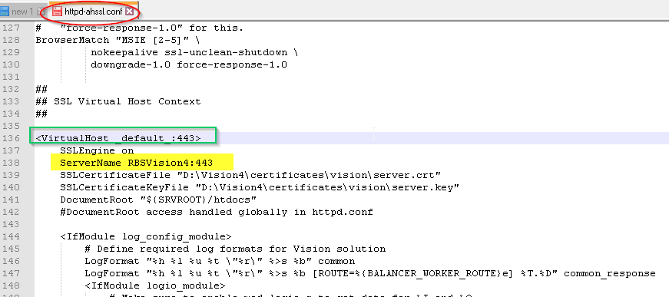

Figure 22

1. Register the certificate in the Certificates / Trusted Root Certification Authorities location of the Vision application server.

* Start **Microsoft Management Console** (Click on the ***Start*** button at the bottom left of the screen, type **MMC** and then select **MMC** from the search find window on the right-hand side of the screen
* Click on ***File*** and select ***Add/Remove Snap-in ….***

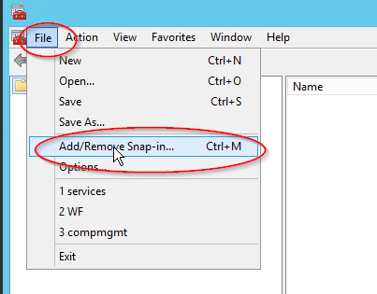

Figure 23

* Select ***Certificates*** and click on ***Add>***

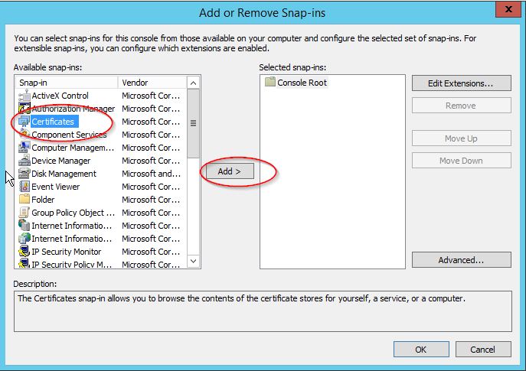

Figure 24

* Select ***Computer account*** and click on ***Next>***

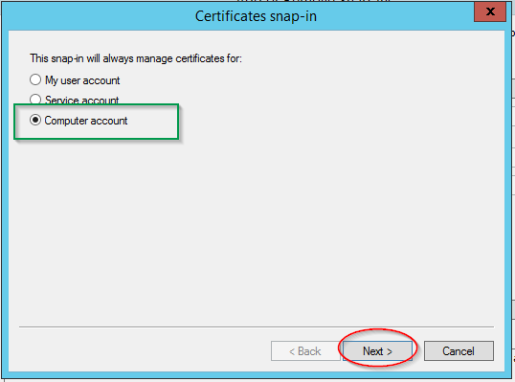

Figure 25

* Verify if ***Local computer*** is selected and click on ***Finish***

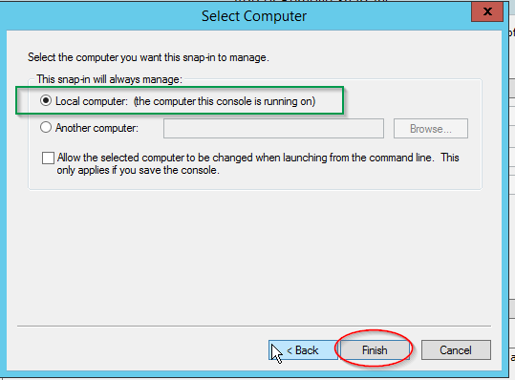

Figure 26

* Verify that ***Certificates*** appear in the ***Selected snap-ins*** window and click on ***OK***

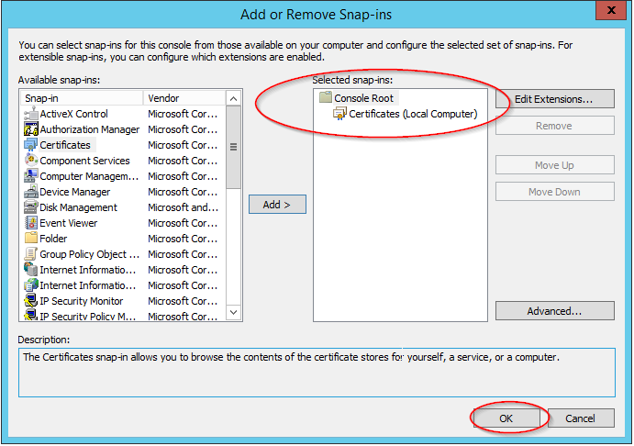

Figure 27

* In the left-hand **Console Root** window, expand **Certificates** and then expand **Trusted Root Certification Authorities.** **Right-click** on **Certificates** (under Trusted Root Certification Authorities), select **All Tasks** and then select **Import….**

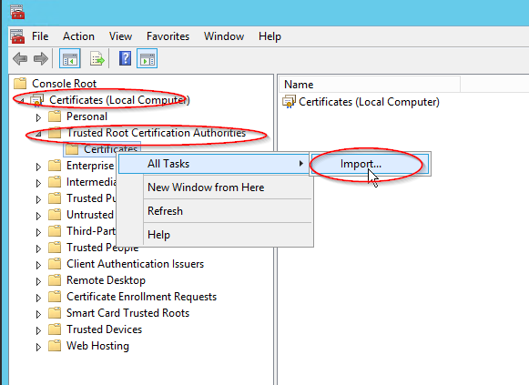

Figure 28

* When the **Certificate Import Wizard** is displayed, verify that **Local Machine** is selected for the ***Store Location*** and click on ***Next***

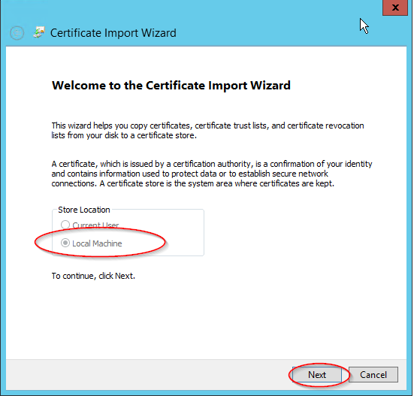

Figure 29

* Browse and select the file ***D:\Vision4\certificates\vision\Server.crt*** and click on ***Next***

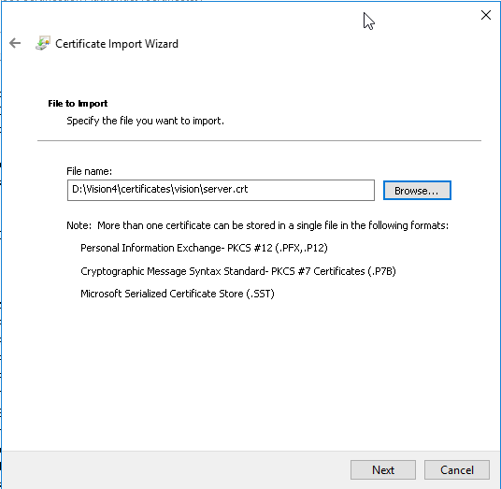

Figure 30

* Verify that **Trusted Root Certification Authorities** are selected as shown, and click on **Next**

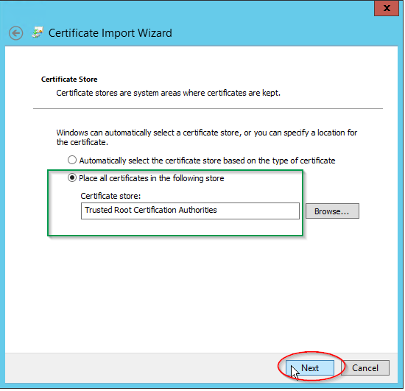

Figure 31

* Review the information displayed and click on ***Finish***.

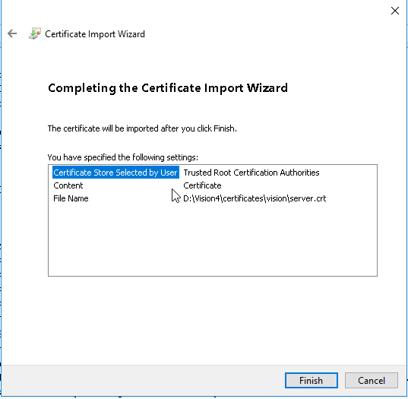

Figure 32

* Click on ***OK*** when the import success message is displayed

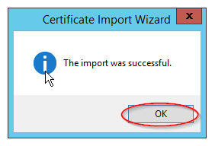

Figure 33

* In the left-hand pane, left click on **Certificates** (under Trusted Root Certification Authorities) and verify that the certificate has been correctly imported.

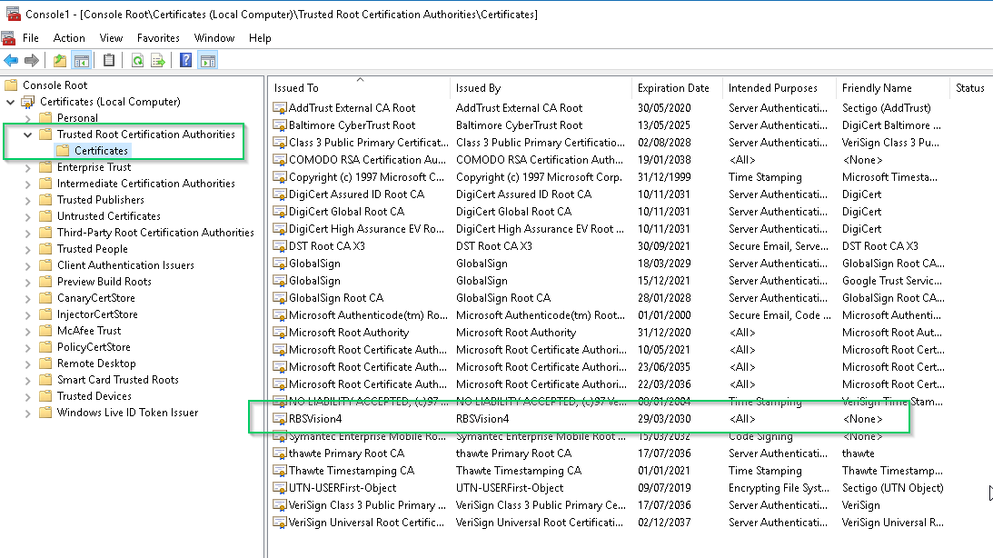

Figure 34

* Exit the Console window. Select **No** when prompted to save settings
* Restart the ***ncr_vision_tomcat*** service and verify that there are no errors in the current error log file (Locate in ***C:\ncr\vision\products\ncr_vision_tomcat\logs***). The entry should look similar to the following:

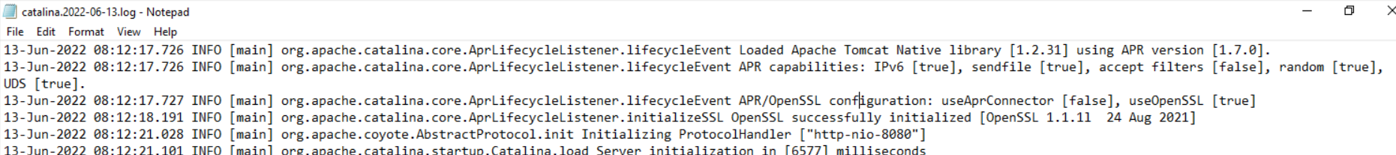

* Restart the ***Application Server*** (this is needed to configure various Windows Environment variables required for the rest of the installation process).

**Note:** Whenever any Vision related service is restarted (or if the Vision application server has been restarted), it is a best practice to use ***Windows Task Manager*** to monitor CPU utilisation. Vision services typically use a lot of processing resources when started. Do not attempt to use the Vision system until CPU % stabilises to a low % (2 or 3% typically)

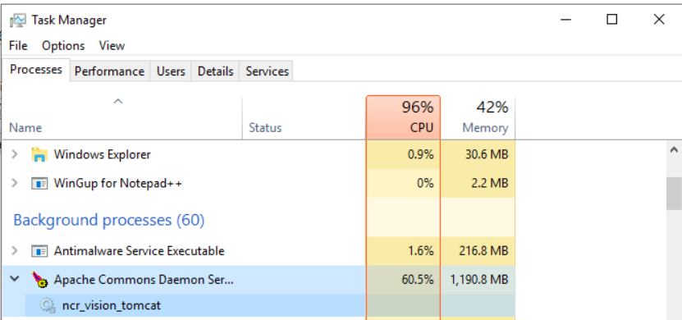

Figure 35

1. Configure Internet Explorer as follows:
2. The Display Internet Sites in Compatibility View feature must be turned **OFF**

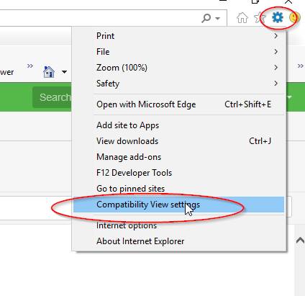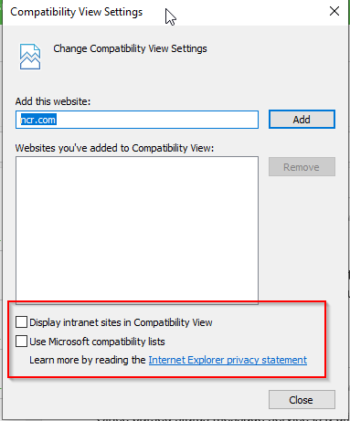

Figure 36

1. **Website Data Settings** must be configured to check for new versions every time the webpage is visited:

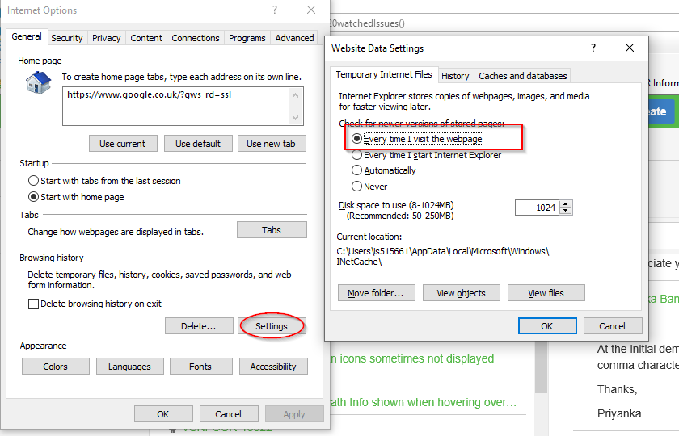

Figure 37

1. when the Vision web services have finished loading (monitor using ***Windows Task Manager***), user can log on to the website via the load balancer URL as previously defined.

*https:// slim418sql/cxp-core-webapp/login*

**Note**: The user may need to disable **IE Enhanced Security Configuration**

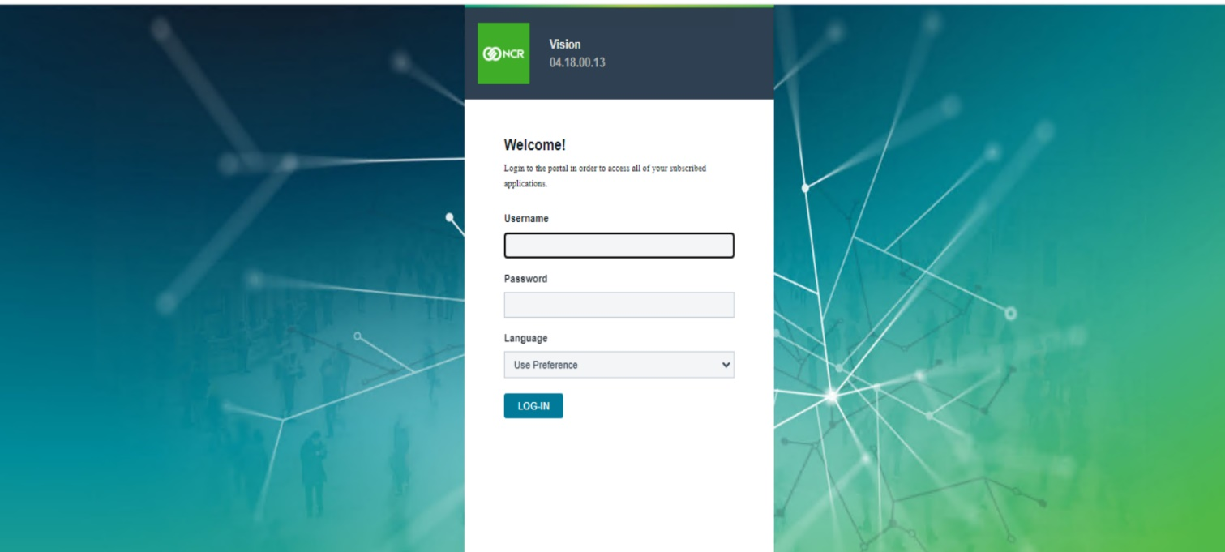

Figure 38

* **Default username**: admin
* **Default password**: Password-100

1. Change the password for the admin user as prompted on the first login
2. Create a new user and assign Admin privileges
3. Log out and Login with the new user created in the previous step
4. Log out when you have verified the new user login works correctly
5. Vision Configuration

## Security Role

Create security roles as required. Recommended roles would be:

* Administrator (defined by the system on installation)
* Serviceline user
* Serviceline power user (remote commands?)
* Serviceline administrator
* Pulse user

## Users

Define system users as required and assign these to the relevant Security Roles(s)

## Category Names

The Category Names will be amended to be the same as the NCB Gasper Vantage v5.5.28 solution.

* + 1. Admin | Data Admin

Figure 39

## Terminal Definition (Import)

On the My Fleet page, select the Terminal Import feature. Navigate to locate the NCB Terminal Definition import CSV file. All defined terminals will be imported in Vision.

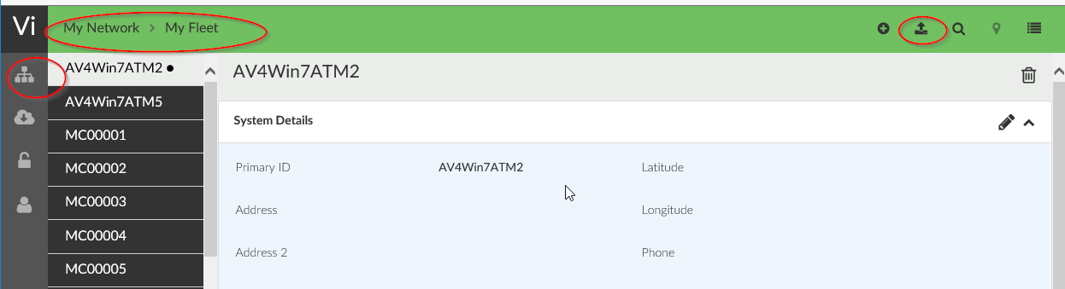

Figure 40

## Terminal Group Definition

1. Select Shared services | Terminal Management

Figure 41

1. Click on the ‘+’ sign at the top right-hand corner to create a new Terminal Group entry



Figure 42

1. Enter the details for NCB and click on Next

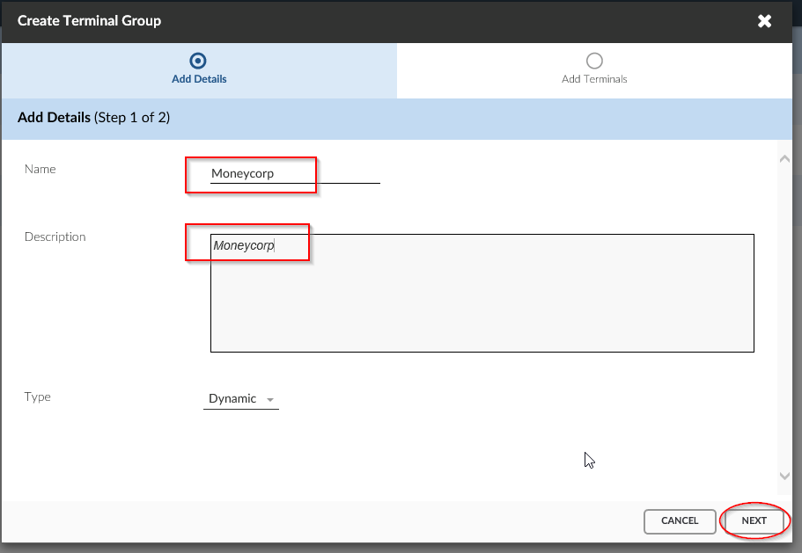

Figure 43

1. Select Primary ID from the drop-down list (which should be selected by default)

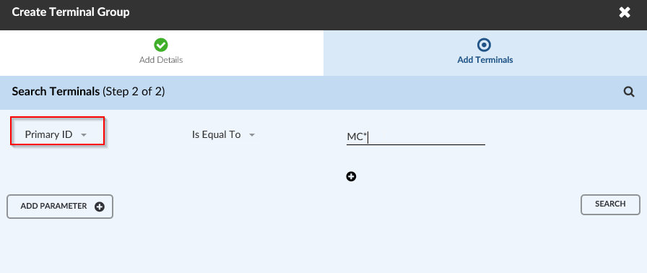

Figure 44

1. Enter MC* in the ‘Is Equal To’ entry area and click on Search. Verify that all NCB ATMs are displayed in the lower pane (146 Terminals) and click on Save.

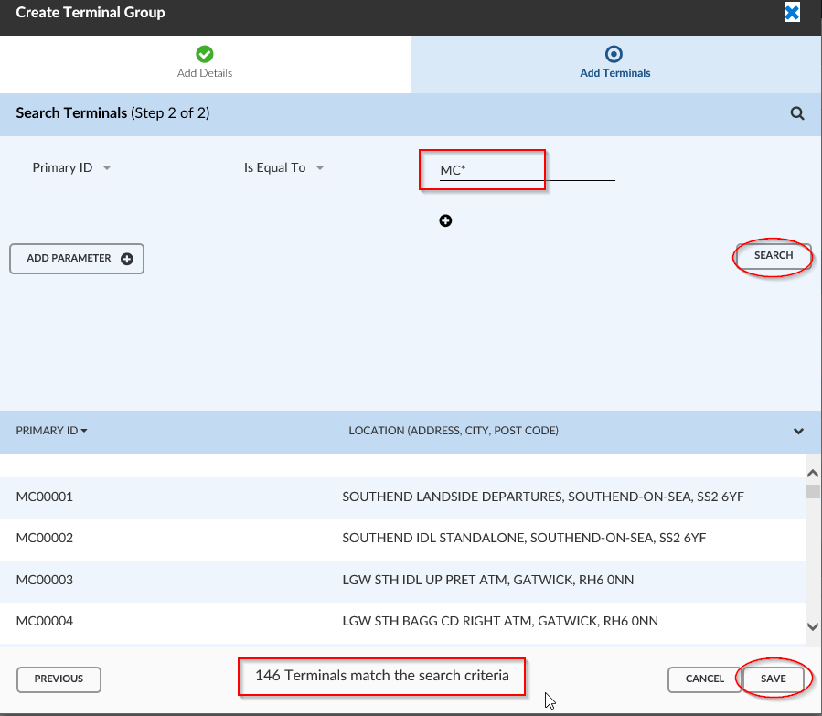

Figure 45

1. Repeat steps 2 to 5 and defines Terminal Groups for

* NCB ATMs UK & Events (256 terminals) – use Primary ID mask RR*
* NCB ATMs EU (27 terminals) – use Primary ID mask RI*

**Note**: Terminal Groups can be assigned to Vision Users as required

Vision Slim Software Solution, Installation and Configuration Guide Version 4.18.0.

www.ncr.com